PLAESTRA FITNESS CENTER SYSTEM

*GROUP MEMBERS*

*AMANDEEP KAUR AUJLA-300823928*

*VISHAVDEEP KAUR-300828926*

*SHAHBAZ SINGH-300817167*

Contents

PROBLEM STATEMENT 4

VISION STATEMENT 4

SYSTEM CAPABILITIES 4

BUSINESS BENEFITS 5

WORK-FLOWS 5

1.0 Member Registration 5

2.0 Member/Employee Check-In 7

3.0 Trainer Booking 7

4.0 Equipment Renting 9

5.0 Patient and office reports 10

USE CASE 10

USE CASE DIAGRAM 16

1.1 MEMBER REGISTRATION 16

1.2–EQUIPMENT RENTING 16

1.3–TRAINER BOOKING 17

1.4-MEMBER/EMPLOYEE CHECK-IN 17

1.5-OFFICE REPORT 18

USE CASE DESCRIPTION 18

PACKAGE 1-MEMBER REGISTRATION 18

PACKAGE 2-EQIUPMENT RENTING 19

PACKAGE 3- TRAINER BOOKING 19

PACKAGE 4- EMPLOYEE/MEMBER CHECK-IN 20

PACKAGE 5- OFFICE REPORT 20

DOMAIN CLASS DIAGRAM 22

DESIGN DETAIL CLASS DIAGRAM 23

CRC CARDS 24

PACKAGE DIAGRAM 25

SEQUENCE DIAGRAMS 26

1. Member Registration 26

2. Rent Equipment 27

27

3. Member/Employee Check-In 27

4. Office Report 28

5. Book Trainer 29

STATE DIAGRAM 29

Sessions 29

Trainer ( 30

Equipment 31

MOCK-UP USER INTERFACES 32

MAIN-MENU 32

MEMBER-CHECK-IN 32

REGISTER 34

RENT EQUIPMENT 35

BOOK MEMBER 36

OFFICE REPORTS 37

Monthly Booking Report 37

Monthly Member Report 39

Monthly Staff Report 40

ERD 42

COMPONENT DIAGRAM 42

DEPLOYMENT DIAGRAM 43

List a set of technology/development tools 43

GANTT CHART 43

Fitness Center System

# PROBLEM STATEMENT

PLALESTRA FITNESS CENTER is a fitness center which has manual system of maintaining records. Recently, the company has planned to expand its business by renting out gym equipment. Also, the company is experiencing huge customer traffic which makes it difficult to maintain records in excel sheets. The company is facing problems involving same people taking free trial a number of times or attending paid classes for free. Also, the company has introduced new packages and increased fee for new customers. Employees find it difficult to differentiate between new and old customers and are unable to charge customers appropriately.

The company also investing in advertisement to increase the number of customers and they require an information system to assist them in these decisions.

## VISION STATEMENT

Upgrade the manual system of the fitness center to an automated computer system. Execute Information System to support and enhance day by day operation with expanded efficiency, while keeping a high level of Customer satisfaction.

## SYSTEM CAPABILITIES

* Register customers and maintain records
* Manage payments
* Book trainers and sessions for members
* Manage schedule for members and trainers as well
* Maintain information about rented equipment
* Assist management in making decisions

## BUSINESS BENEFITS

* Increase in customer satisfaction due to fast processing
* Expansion of business by handling multiple trainers and sessions
* Lead to faster and efficient management decisions
* As opposed to the manual system the proposed information system will allow a more efficient management of the fitness center

# WORK-FLOWS

### Member Registration

* 1. Employee asks for Customer Information
  2. Customer provides information
  3. Employee performs system check for previous record.
     + 1. Employee asks details and valid proof to make a new record.
       2. Customer provides details
       3. Employee verifies the details.
       4. System updates the record.

` 1.3.2 For returning customer, old profile is retrieved.

1.3.2.1 Employee ask to update info

1.3.2.2 Customer provides details

1.4 Employee asks for membership plan.

1.4.1 Customer makes payment if the membership plan is on Contract or month to month.

1.4.1.2 System updates the record

1.4.1.3 Employee activates the membership card

1.4.2 Employees provides 2 day passes if Customer wants free trial.

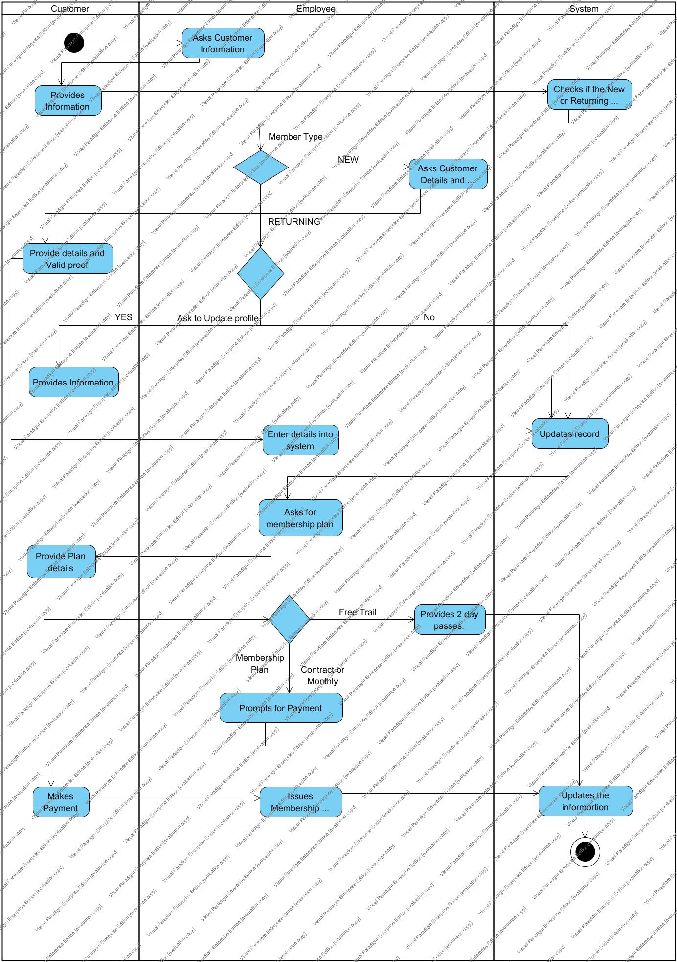

### Member/Employee Check-In

* 1. Member/Employee approaches Check-in machine.
  2. Slides the ID card.
     1. For Employee, System prompts authority code.

2.3.1.1. Employees enters the authority code.

2.3.1.2 System verifies and update the check-in.

2.3.2 For Member, System update the check-in.

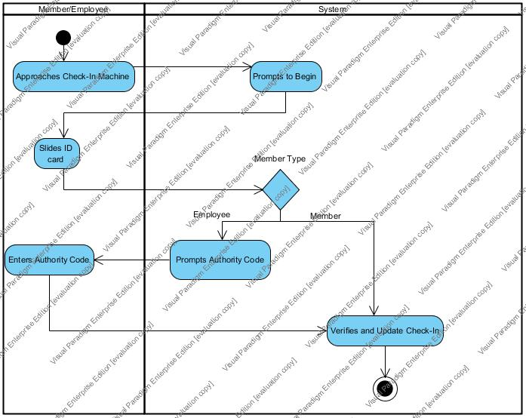

### Trainer Booking

3.1Customer asks for personal trainer.

3.2Employee asks the classification type and schedule.

* 1. Customer provides information.
  2. Employee enters the details into the system
  3. System automatically shortlist the available trainers.
  4. Customer selects a trainer.

3.7.1 Employee saves and updates the record into the system if the Customer is on Contract.

3.7.2 System generates total amount for the booking if the Customer on Monthly plan.

3.7.2.1 Customer makes payment.

3.7.2.2. System records the transaction.

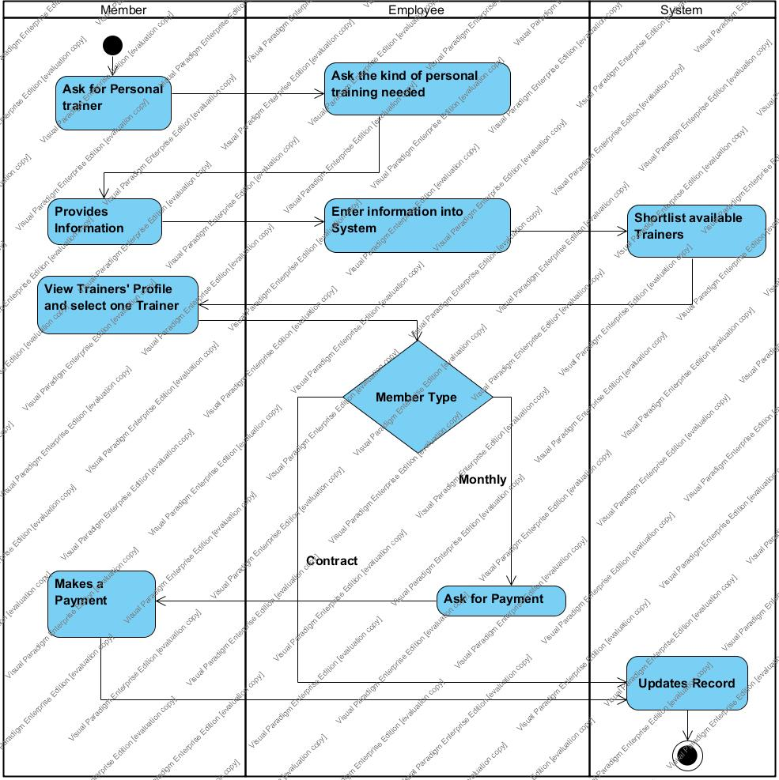

### Equipment Renting

* 1. Customer asks for an equipment(s).
  2. Employee asks for Membership ID card.
  3. Employee scans the ID card.

4.4 Employee scans the equipment tag.

4.5 System update the equipment information into the Customers profile.

4.6 System generates the receipt indicating the due date.

4.7 Employee gives the equipment and receipt to the Customer.

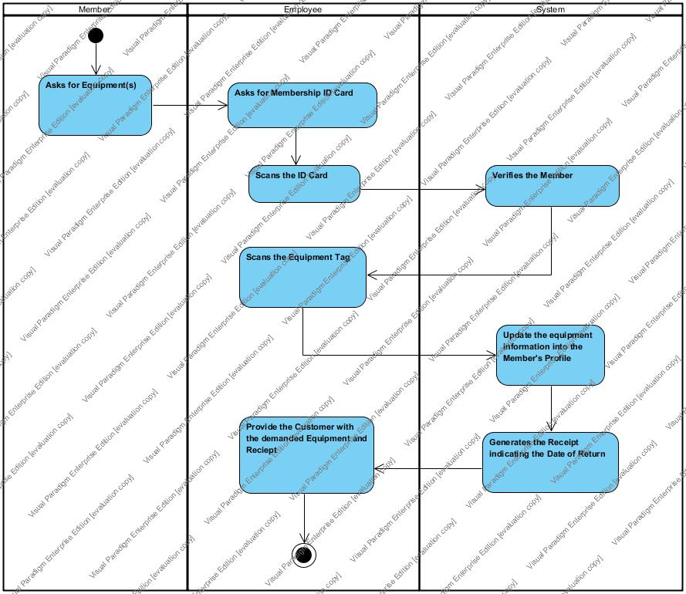

## 5.0 Patient and office reports

5.1 User (Employee or Manager) requests report.

5.2 System displays the different types of reports. (Monthly Member Reports, Monthly Staff Reports, Monthly Booking Reports

5.3 User selects report type.

5.4 System displays the report.

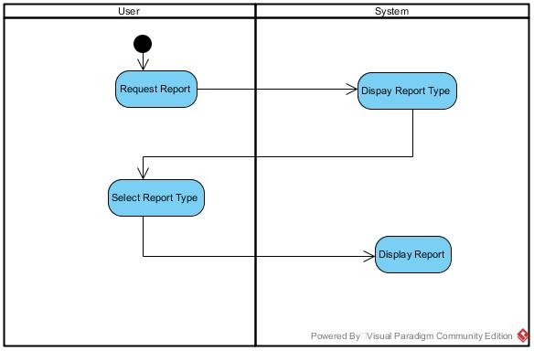

# USE CASE

|  |
| --- |
| PROCESSES (Workflows): |
| 1. Member Registration |
| 1. Equipment Renting |
| 1. Trainer booking |
| 1. Member/Employee Check-In |
| 1. Office Reports |

The Processes correspond to the Functional areas of the Use Case Model shown below:

|  |  |  |  |  |  |  |  |
| --- | --- | --- | --- | --- | --- | --- | --- |
| No. | Actor | Goal Use Case | <Include> | <Extend> | Generalization | Priority | Brief Description |
| 1.1 | Employee | Register as a member | * Get Payment * Activate Membership Card | * Book trainer * Book Session | * Member pays monthly * Member is on a contract | H | Employee registers customer as a new member |
| 1.2 | Employee | Register as a customer | * Verify customer info * Print two day passes |  |  | H | Employee registers a new customers and provides passes for free trial |
| 1.3 | Employee | Search member /customer details |  | * Add as a member * Search all customer/member data |  | M | Employee can search member details of a single or all members. |
| 1.4 | Employee | Maintain Payment Details |  | Print Payment Details |  | L | Employee can view or alter payment details and print them |
| 1.5 | Employee | Update member/customer details |  |  |  | M | Employee can modify customer or member details as required |
| 2.1 | Employee  Member | Check-In. | Scan membership/staff card |  |  | M | Members or employee can check-in and mark their attendance |
| 2.2 | Employee  Staff | View Member Attendance Details |  |  |  | M | Employee or Manager can view attendance details of members at fitness center |
| 2.3 | Manager | View Staff Attendance |  |  |  | M | Manager can view attendance details of staff |
| 3.1 | Employee | Book Trainer | * Confirm Membership type * Check member schedule * Check trainer schedule | * Get Payment |  | H | Employee books trainer for members by considering schedules of both trainer and member. Also if the member pays monthly and is not on contract then employee gets payment from member |
| 3.3 | Employee | Update training schedule | •Check member schedule  •Check trainer schedule   * Get current training schedule |  |  |  | Employee makes changes on training schedule depending on member or trainer request |
| 3.4 | Employee | View members under a trainee |  |  |  | H | Employee can view members under a trainee when asked by a member or a trainee |
| 3.5 | Employee | View Trainer Details |  |  |  | L | Employee can view trainer details when requested by a member |
| 3.6 | Employee | Cancel Booking |  |  |  | L | Employee cancels training as requested by trainer or employee |
| 4.1 | Employee | Rent Equipment | * Scan Equipment * Confirm Membership * Update on member account | Generate receipt |  | H | Employee rents equipment by scanning the equipment and confirm the membership status of member. Employee then updates the rented equipment on member’s account. |
| 4.2 | Employee | Get Equipment Returned | * Update on member account | Generate receipt |  | M | Employee scans the equipment and takes off it from the member account |
| 4.3 | Employee | View Rented Equipment Details |  |  |  | H | View Rented Equipment Details: Employee can view details of rented equipment. |
| 5.1 | Employee  Management | View Monthly Booking Reports |  |  |  | H | Employee and members can view Monthly Booking Reports |
| 5.2 | Employee  Management | View Monthly Member Reports |  |  |  | H | Employee and members can view Monthly Member Reports |
| 5.3 | Management | View Monthly Staff Reports |  |  |  | H | Management can view monthly staff reports. |

# USE CASE DIAGRAM

### 1.1 MEMBER REGISTRATION

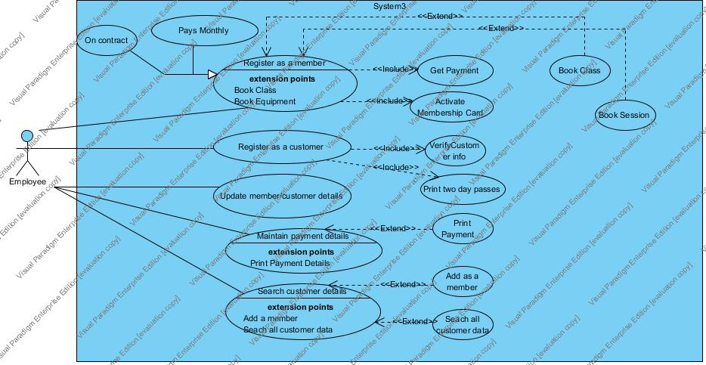

### 1.2–EQUIPMENT RENTING

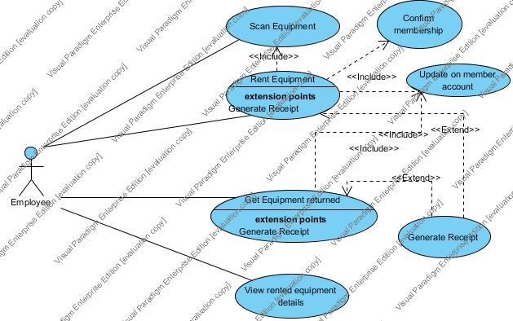

### 1.3–TRAINER BOOKING

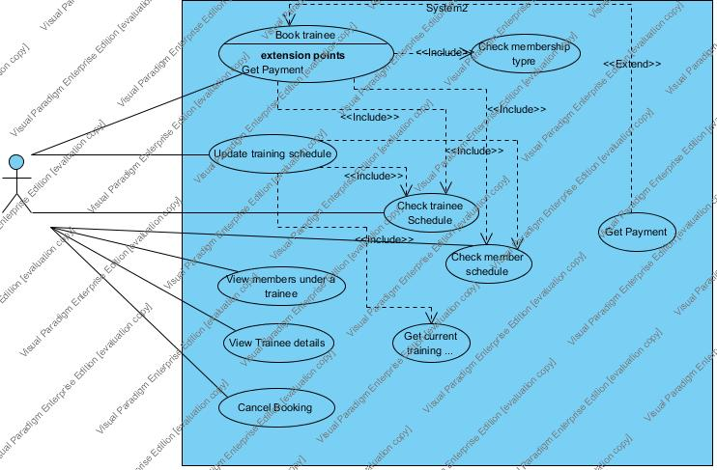

### 1.4-MEMBER/EMPLOYEE CHECK-IN

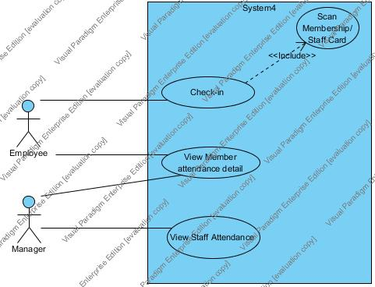

### 1.5-OFFICE REPORT

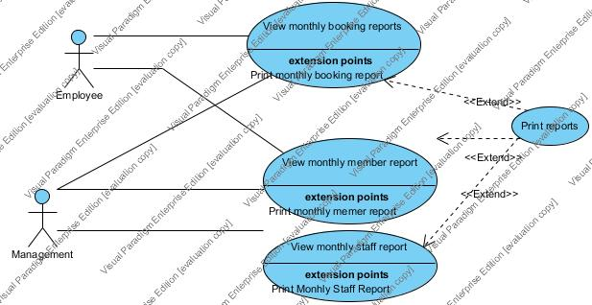

# USE CASE DESCRIPTION

## PACKAGE 1-MEMBER REGISTRATION

|  |
| --- |
| REGISTER A MEMBER |
| 1.1 |
| Customer can be registered as a member if he pays for the service. Member can pay monthly or pay the whole fee at once. If they pay the whole fee at once would be then treated as on contract and they can book trainer or any other session for free. When member is registered his membership card is activated. While registration, member can also book a session or a trainee. |

|  |
| --- |
| REGISTER A CUSTOMER |
| 1.2 |
| Employee registers a new member as a customer after verifying that he was not registered before or hasn’t taken free trials before. Employee then prints two day free passes for the customer. |

|  |
| --- |
| UPDATE MEMBER/CUSTOMER DETAILS |
| 1.3 |
| Employee can view payment details of members and based on these details he can send emails regarding fee payment. He can also print out the details. |

|  |
| --- |
| UPDATE MEMBER/CUSTOMER DETAILS |
| 1.3 |
| Employee can view payment details of members and based on these details he can send emails regarding fee payment. He can also print out the details. |

|  |
| --- |
| SEARCH CUSTOMER DETAILS |
| 1.4 |
| Employee can search customer data. He can view a particular customer data and change his status to member from a customer or he can search all customer data. |

## PACKAGE 2-EQIUPMENT RENTING

|  |
| --- |
| Rent Equipment |
| 2.1 |
| Employee can rent equipment by scanning the equipment and confirming that the customer is a member. Employee then updates the rent equipment info on member s account. Employee can also print ARECEIPT to be given to the member. |

|  |
| --- |
| Get Equipment returned |
| 2.2 |
| Employee scans the equipment and takes off it from the member account |

|  |
| --- |
| View Rented Equipment Details |
| 2.3 |
| Employee can view details of rented equipment. |

## PACKAGE 3- TRAINER BOOKING

|  |
| --- |
| Book Trainee |
| 3.1 |
| Employee books trainer for members by considering schedules of both trainer and member. Also if the member pays monthly and is not on contract then employee gets payment from member |

|  |
| --- |
| View Member Under Training |
| 3.2 |
| Employee can view members under a trainee when asked by a member or a trainee |

|  |
| --- |
| View Tainee Details |
| 3.3 |
| Employee can view trainer details when requested by a member |

|  |
| --- |
| Update Training Schedule |
| 3.4 |
| Employee makes changes on training schedule depending on member or trainer request |

|  |
| --- |
| Cancel Booking |
| 3.5 |
| Employee cancels training as requested by trainer or employee |

## PACKAGE 4- EMPLOYEE/MEMBER CHECK-IN

|  |
| --- |
| Check –IN |
| 4.1 |
| Employee or member can mark their attendance by scanning their membership or staff cards respectively. If the person is Employee, the System will prompt for authority code to enable the process. If the person is Customer, System scans the card and update the record. The Check-In tracks the record of number of people utilizing the Center facilities. |

|  |
| --- |
| View Staff Details: |
| 4.2 |
| Manager can view staff details as well as attendance details |

|  |
| --- |
| View Member details: |
| 4.3 |
| Manager or employee can view member details as well as attendance details |

## PACKAGE 5- OFFICE REPORT

|  |
| --- |
| View Monthly Booking Reports |
| 5.1 |
| Employee and members can view Monthly Booking Reports. Record can be printed. |

|  |
| --- |
| View Monthly Member Reports |
| 5.2 |
| Employee and members can view Monthly Member Reports. Record can be printed. |

|  |
| --- |
| View Monthly Staff Reports |
| 5.3 |
| Management can view monthly staff reports. Record can be printed. |

# DOMAIN CLASS DIAGRAM

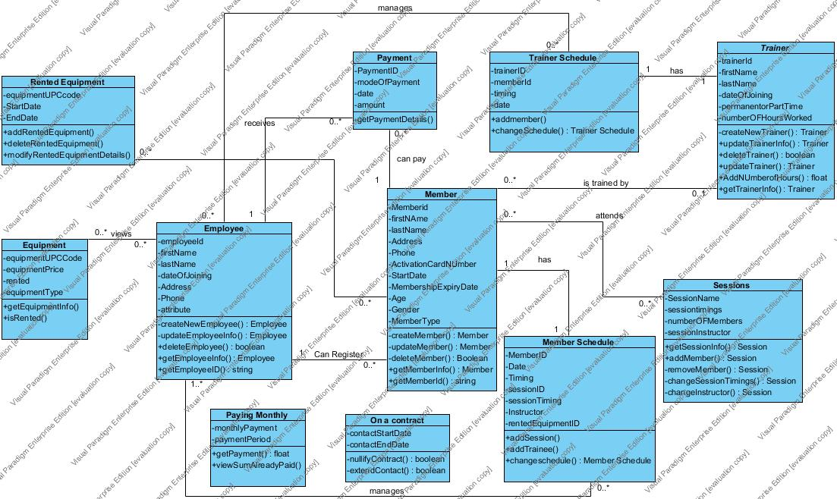

# DESIGN DETAIL CLASS DIAGRAM

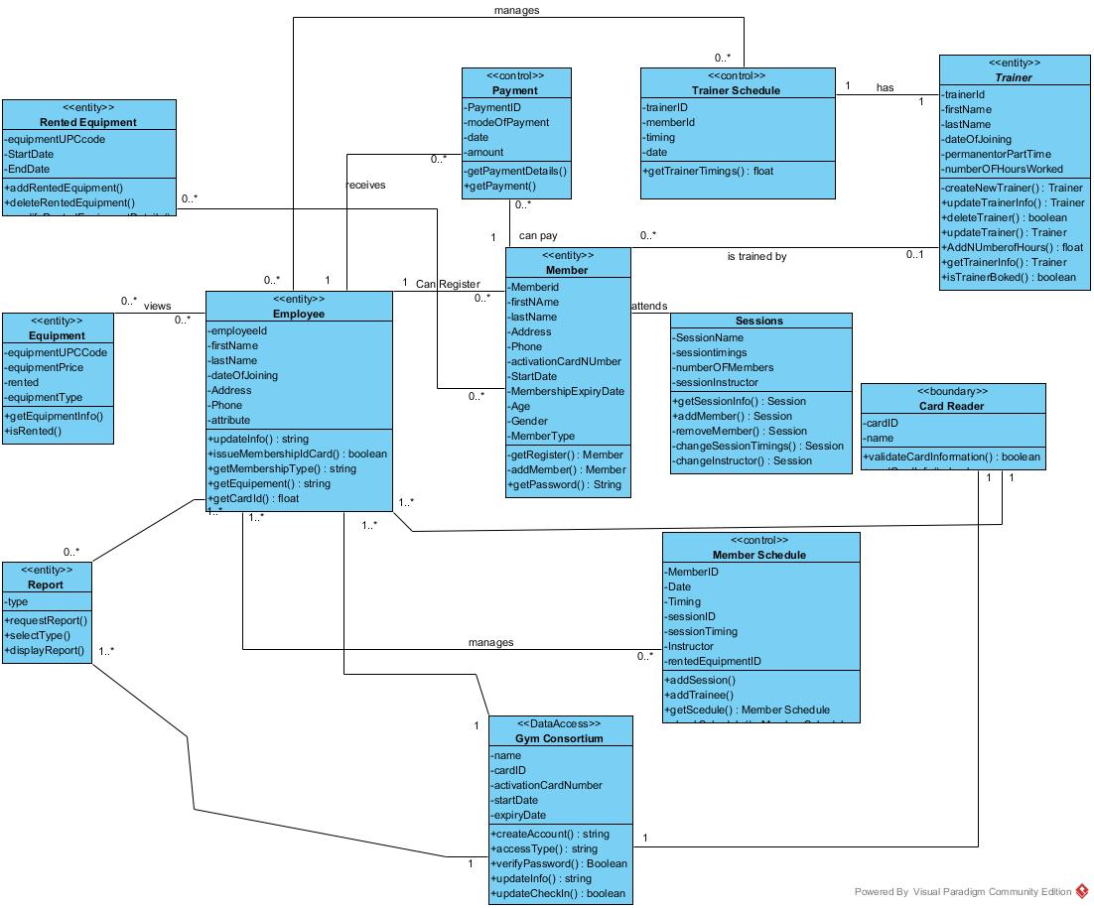

# CRC CARDS

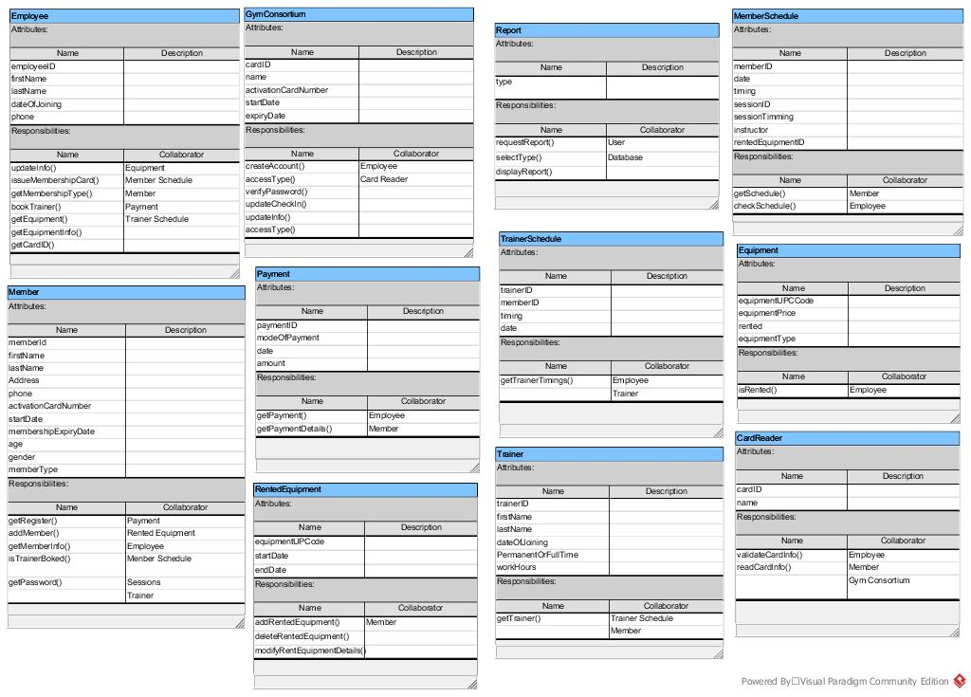

# PACKAGE DIAGRAM



# SEQUENCE DIAGRAMS

## Member Registration

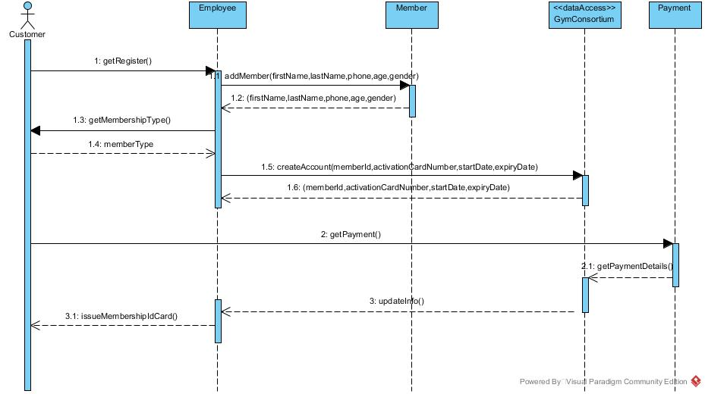

## Rent Equipment

## 

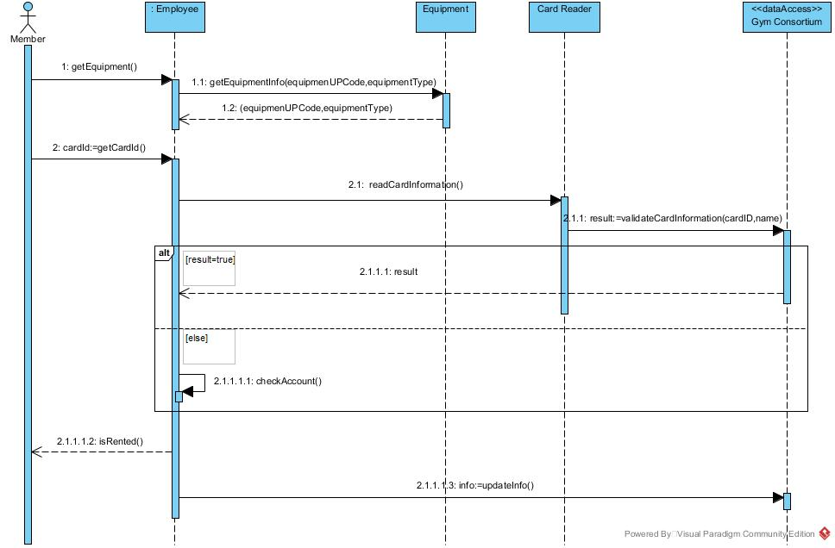

## Member/Employee Check-In

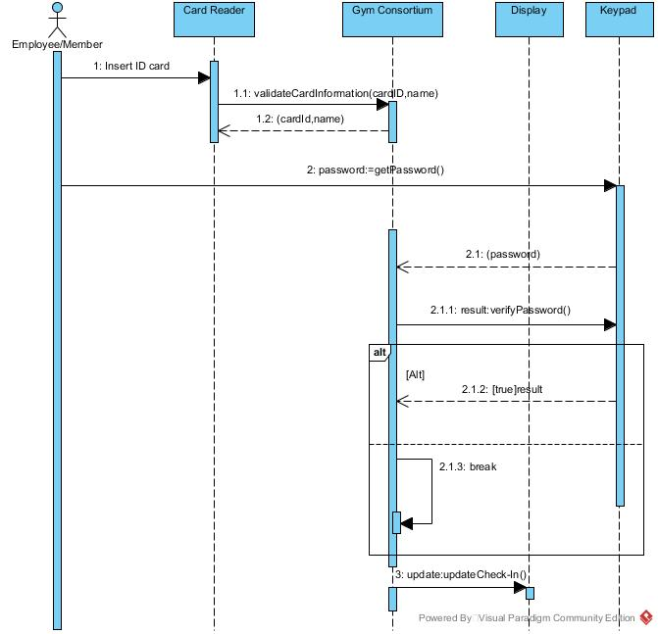

## Office Report

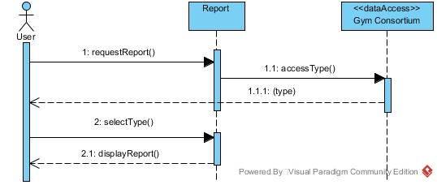

## Book Trainer

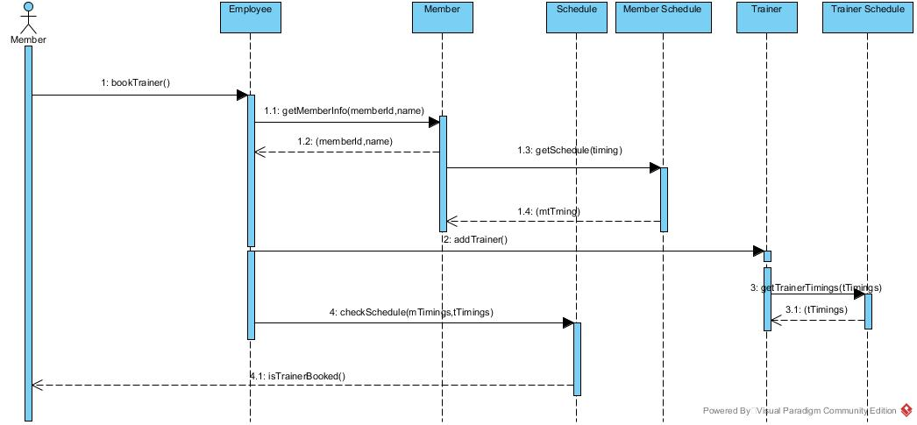

# STATE DIAGRAM

## Sessions

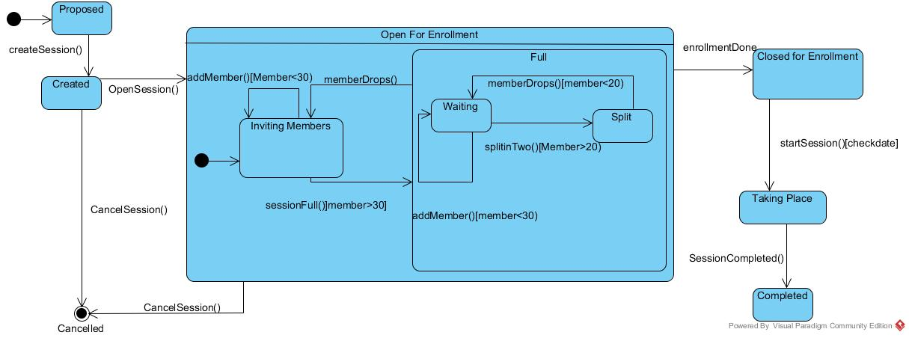

Trainer (Trainer can provide training even when he is open for booking or close for booking)

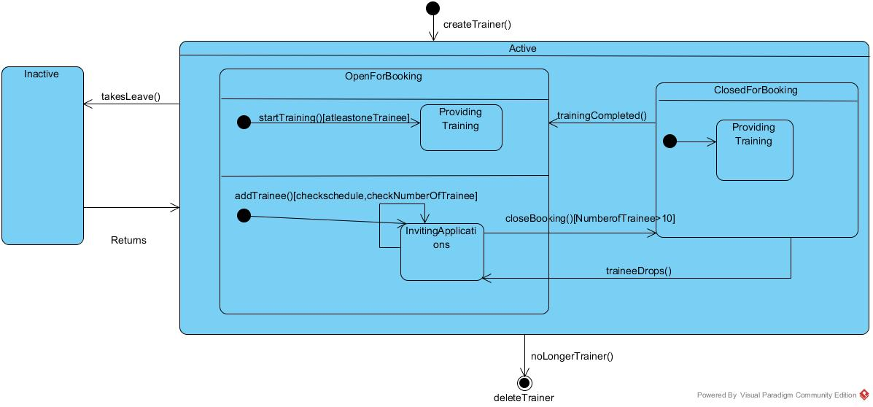

## Equipment

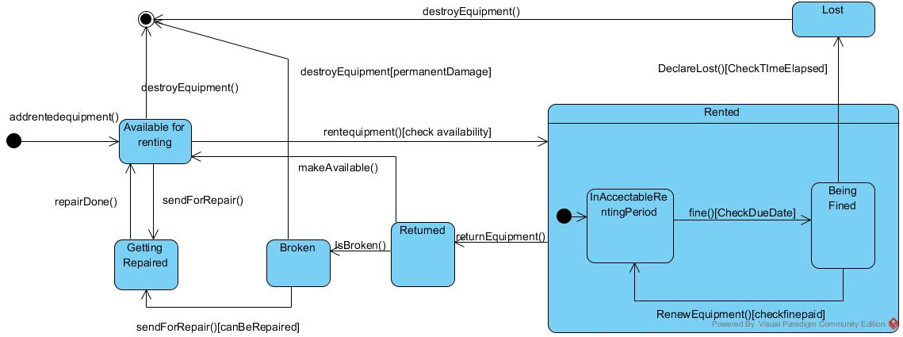

# MOCK-UP USER INTERFACES

## MAIN-MENU

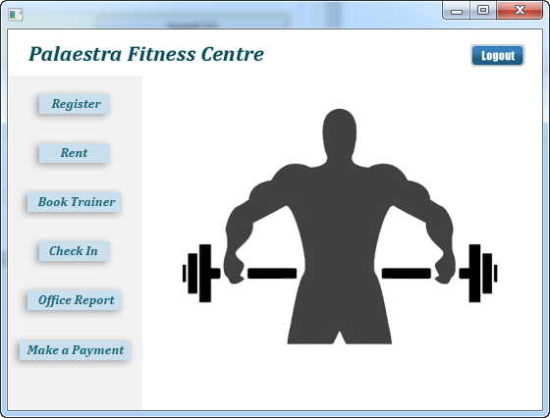

## MEMBER-CHECK-IN

1. Check-In dialog box. User will click as according to its identity.

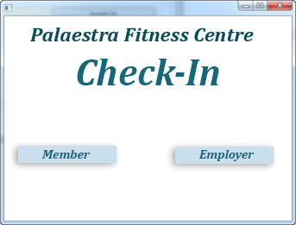

1. User will swipe ID card.

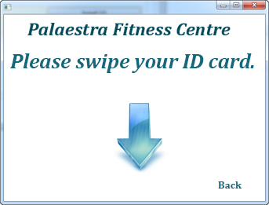

* 1. If user is Employee, he has to enter authentication code.

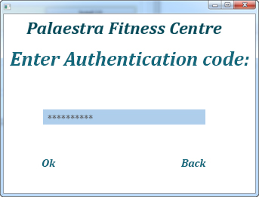 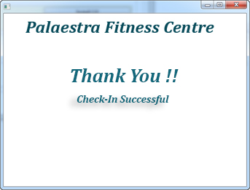

* 1. If user is Member, then directly record will be updated.



# REGISTER

# 

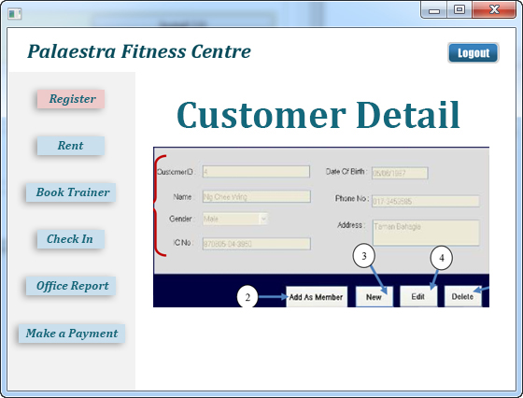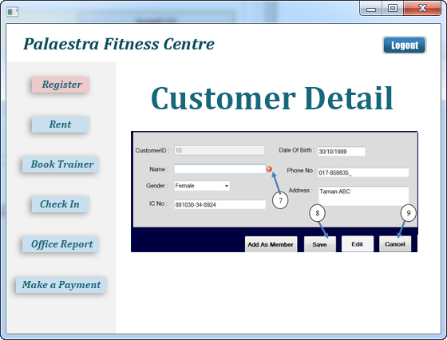

## RENT EQUIPMENT

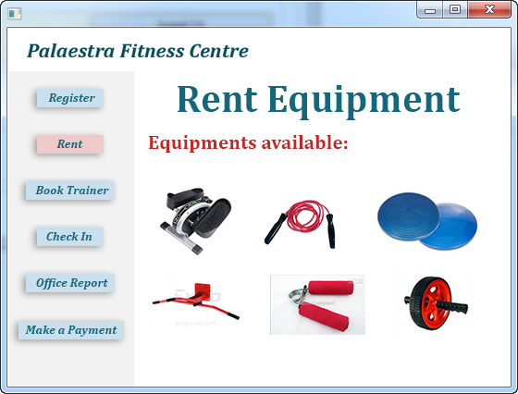

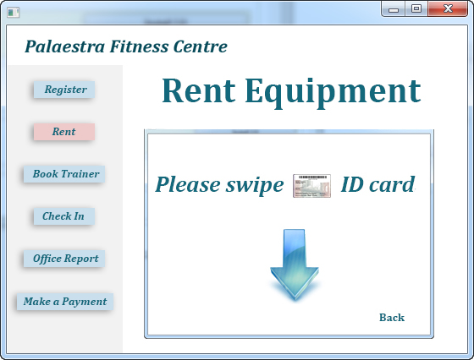

## BOOK MEMBER

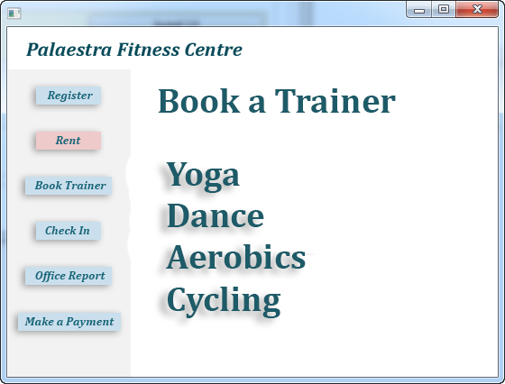

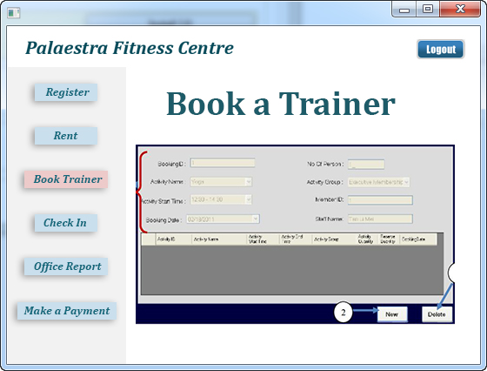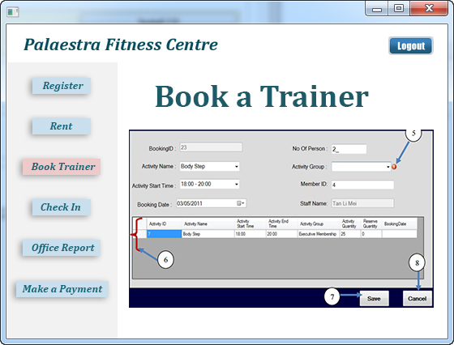

## OFFICE REPORTS

### Monthly Booking Report

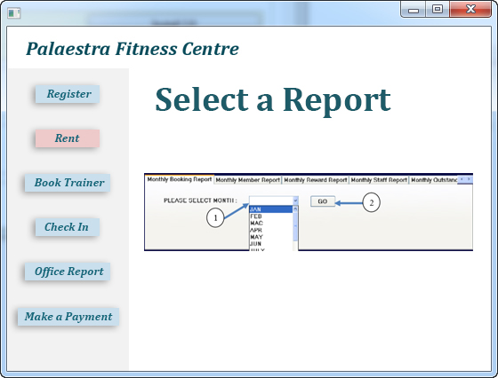

1. Click Month drop down list to select the Month.

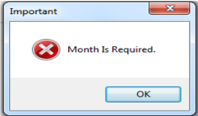

This message will show when user do not select the month.

1. Click to search monthly booking data.

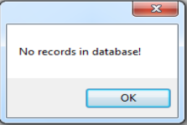

This message will show when no record in database.

Monthly Booking Report

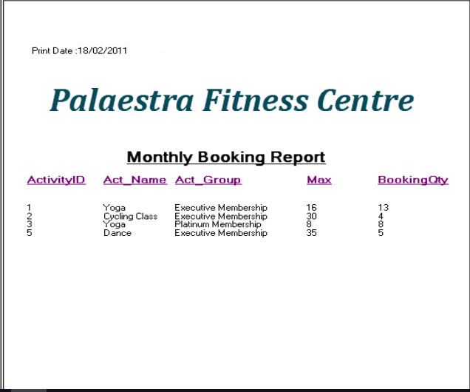

### Monthly Member Report

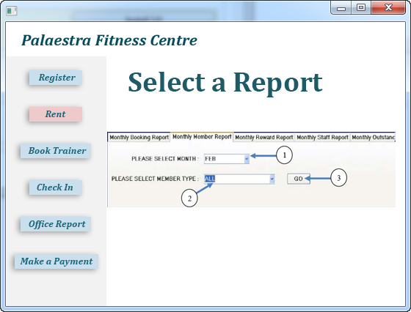

1. Click Month drop down list to select the Month

This message will show when user do not select the month.

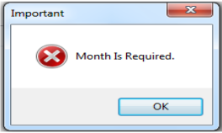

1. Click Member Type drop down list to select the member type.

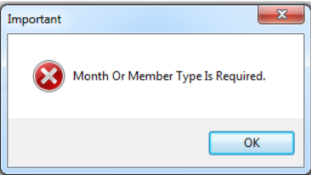

1. Click to search monthly member data

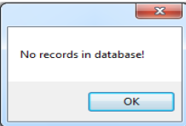

This message will show when no record in database.

Monthly Member Report

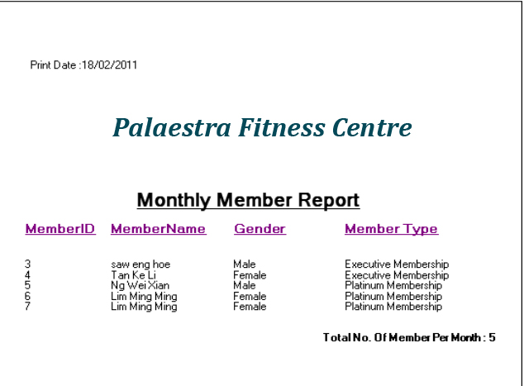

### Monthly Staff Report

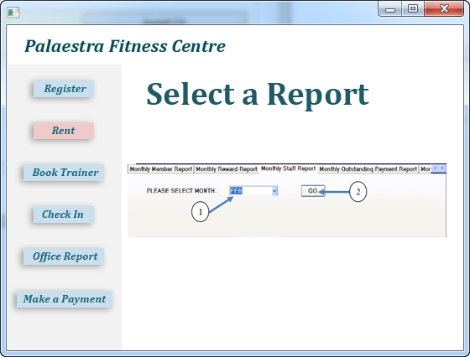

1. Click Month drop down list to select the Month.



This message will show when user do not select the month.

1. Click to search monthly booking data.



This message will show when no record in database.

Monthly Member Report

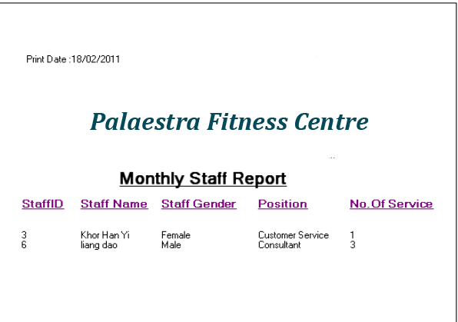

# ERD

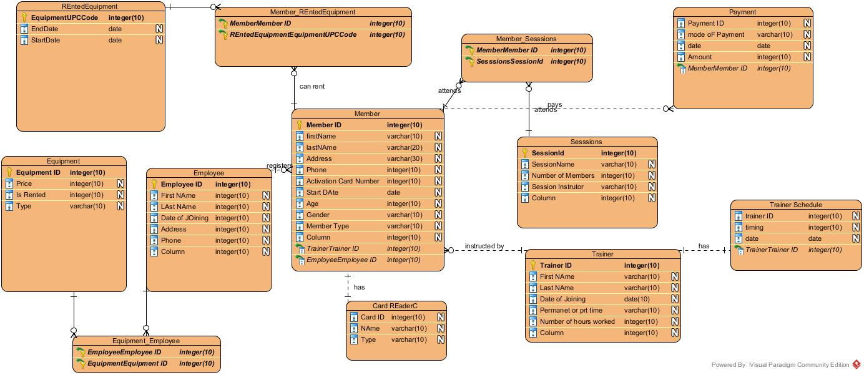

# STUB CODE

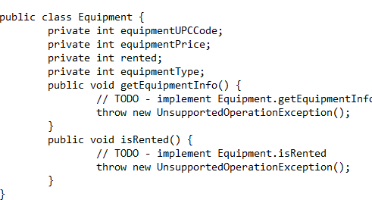

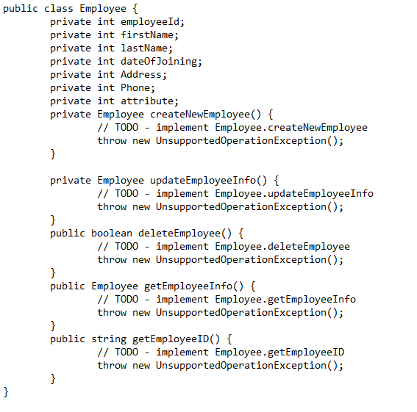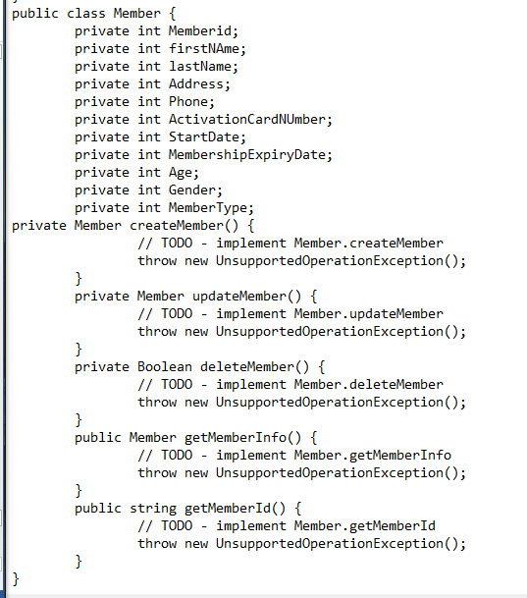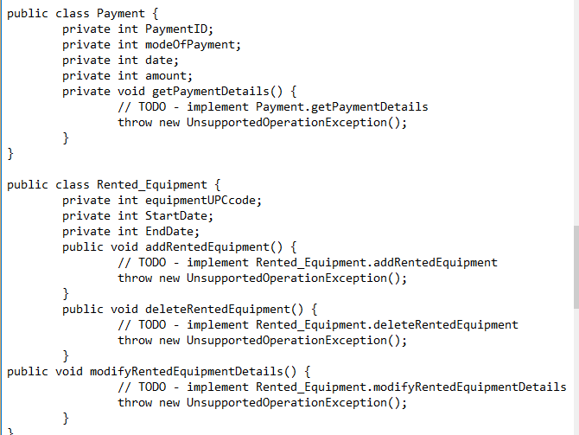

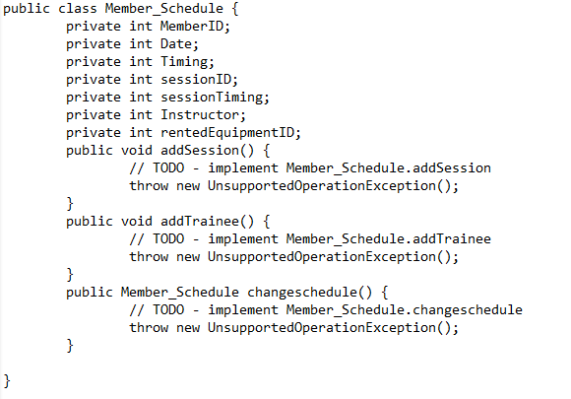

# 

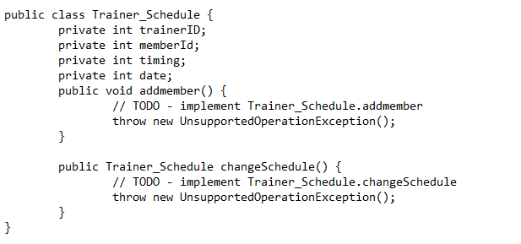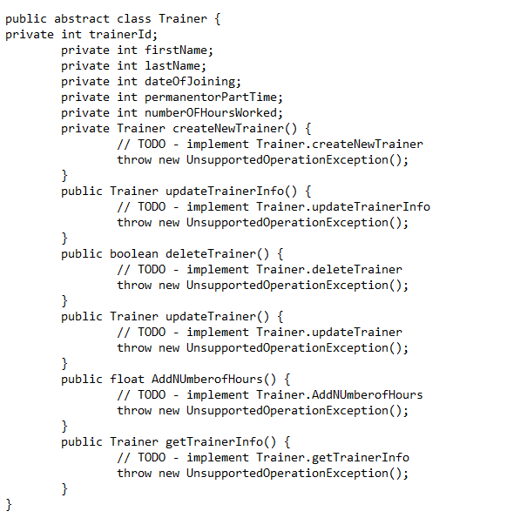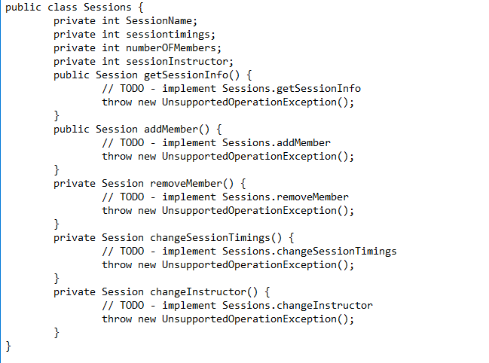

# COMPONENT DIAGRAM

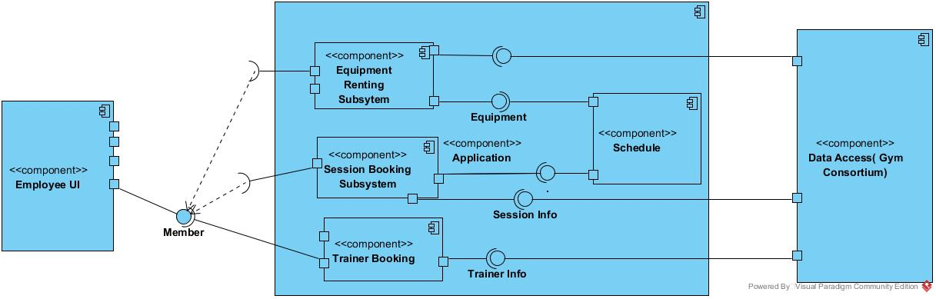

# DEPLOYMENT DIAGRAM

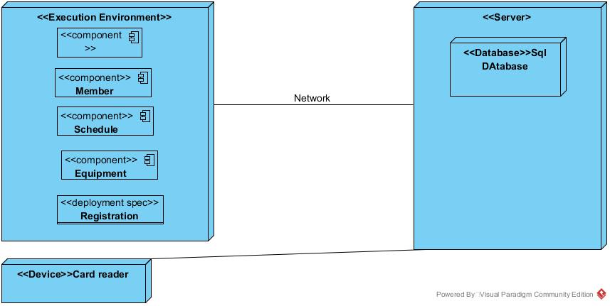

# List a set of technology/development tools

|  |  |  |
| --- | --- | --- |
| 3-Tier Architecture | Development Tools | Comments |
| Presentation Tier | Java  Adobe Photoshop CC | Developers use to create applications with a web plug-in that allows you to design and test the apps. |
| Business Logic Tier | Java  XML | Major features to accommodate functional-style programming and attaining commands over logical statements. |
| Data Tier | SQL Server | It is used to store and update information that needs to be changed in various states. |

# GANTT CHART

